1. **The newly created point feature class (geodatabase) displayed in ArcGIS Pro (label the points using the Type column)**

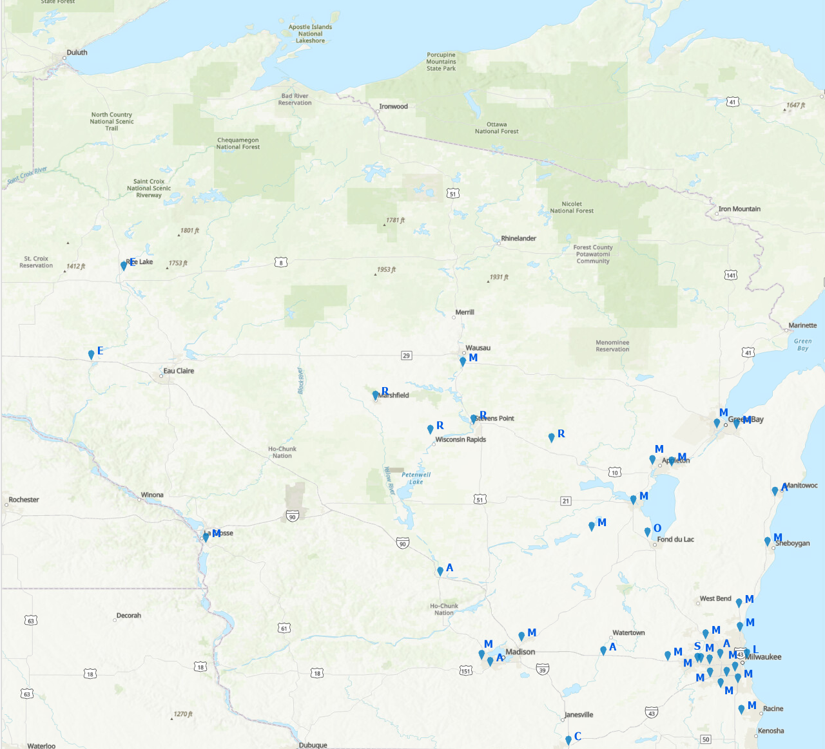

1. **The database as it is displayed in ArcGIS Pro when the open table option is selected**

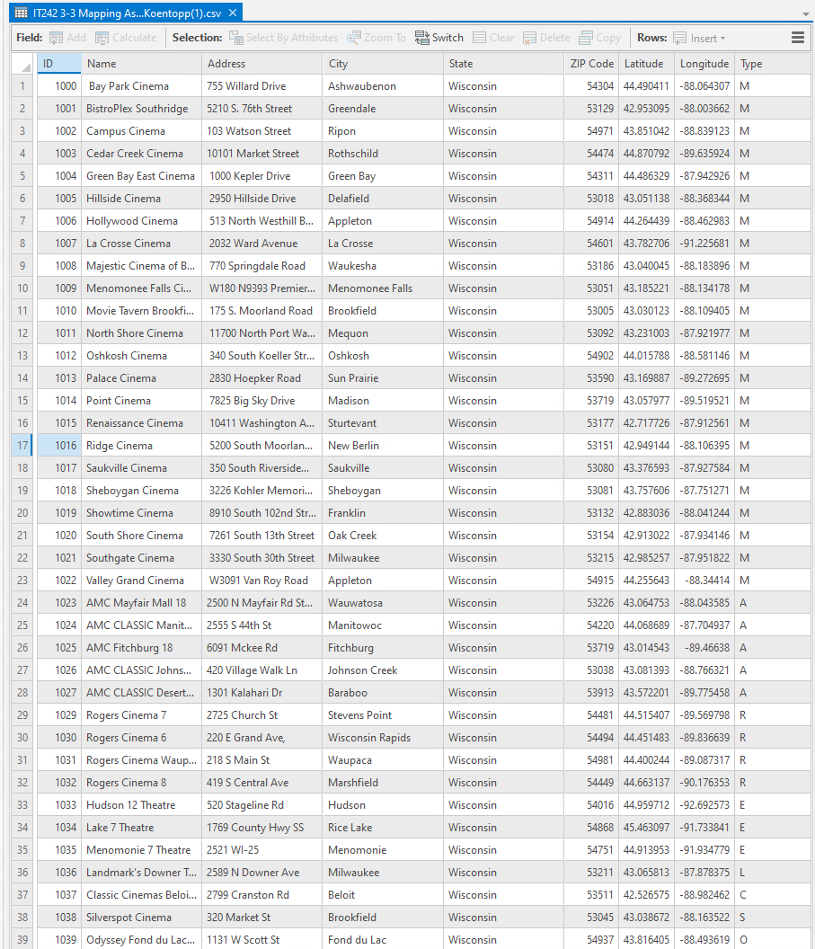**` `**

1. **The feature class (geodatabase) as it is displayed in the Catalog pane**

